The Whitehouse PRU

PSHE and RSE Policy

1 | Summary | PSHE and RSE Policy
2 | Responsible person | Donna Kaye
3 | Accountable SLT member | Head of School – Jake Thompson
4 | Applies to | ☒All staff  ☐Support staff  ☐Teaching staff
5 | Who has overseen development of this policy | Jake Thompson, Nicola Witham
6 | Who has been consulted and recommended policy for approval | Jake Thompson
7 | Approved by and date | Nicola Witham 19/10/2023
8 | Version number | 2.0
9 | Available on | Every | ☐Y  ☒N | Trust website  Academy website  SharePoint | ☐Y ☐N  ☒Y ☐N  ☒Y ☐N
10 | Related documents (if applicable)
11 | Disseminated to | ☒Trustees/governors  ☒All staff  ☐Support staff  ☐Teaching staff
12 | Date of implementation (when shared) | 19/10/2023
13 | Consulted with recognised trade unions | ☐Y ☒N

Contents
1. Introduction 4
2. Aims 5
3. Objectives and Pupil Learning Intentions 6
4. Statutory Requirements 7
5. Equalities 9
6. Policy Development 9
7. Curriculum 10
8. Delivery of PSHE and RSE 11
9. Access to the RSE Curriculum for Pupils with SEND 13
10. Roles and Responsibilities 14
11. Right to Withdraw 17
12. Training and Monitoring 18
13. Differentiation and SEN 18
14. Safeguarding 18
15. Appendix 19

Introduction

All schools must provide a curriculum that is broadly based, balanced and meets the needs of all pupils. Under section 78 of the Education Act 2002 and the Academies Act 2010, a PSHE curriculum:
- Promotes the spiritual, moral, cultural, mental and physical development of pupils at the school and of society, and
- Prepares pupils at the school for the opportunities, responsibilities and experiences of later life.

At Whitehouse PRU, we teach Personal, Social, Health, Economic Education including the statutory requirements of Relationships and Sex Education as a whole-school approach to underpin children’s development and enable them to understand and respect who they are and to equip them for life and learning.
We provide a personalised approach to PSHE with a broad and rich curriculum, which aims to support the future success of all pupils, with a focus on supporting children with SEND and disadvantaged backgrounds. Our PSHE curriculum is sequential and progressive using Jigsaw and bespoke sessions informed by the PSHE Association, NSPCC and Lifesavers. Jigsaw is written as a universal core curriculum provision for all children with inclusivity as part of its philosophy. In addition to Jigsaw we tailor our lessons to meet our pupil's needs incorporating the PSHE Association resources, NSPCC and Lifesavers resources and follow half-termly calendared health events delivered by external visitors. Our pupils are encouraged to take part in a wide range of activities and experiences across and beyond the curriculum, supporting their “Personal Development” and “Behaviour and Attitude” aspects required under the Ofsted Inspection Framework, as well as significantly contributing to the school’s Safeguarding and Equality Duties, the Government’s British Values agenda and the SMSC (Spiritual, Moral, Social, Cultural) development opportunities provided for our children.

Our RSE offer is included within PSHE following the DfE statutory guidance (2019) stating that all primary aged children learn about the ‘changing adolescent body’, included in the expected outcomes for primary Health Education. It states Effective Relationships and Sex Education can significantly contribute to the development of the personal skills needed, by pupils, to establish and maintain relationships. It also enables children to make responsible and informed decisions about their health and well-being. This is why the DfE recommend “ that all primary schools should have a sex education programme tailored to the age and the physical and emotional maturity of the pupils. It should ensure that both boys and girls are prepared for the changes that adolescence brings and - drawing on knowledge of the human life cycle set out in the national curriculum for science - how a baby is conceived and born.” (Relationships Education, Relationships and Sex Education, and Health Education, DfE, 2019, para 67).

At Whitehouse PRU we are confident that the Jigsaw Programme and our approach following the PSHE Association covers all aspects of Relationships, Sex and Health Education (RSE) within the context of a full PSHE programme in an age- appropriate way.

Aims

- To provide pupils with the knowledge, understanding, attitudes, values and skills they need to reach their potential as individuals.
- To deliver a wider range of experiences through the delivery of a bespoke programme use of external visitors from the community, e.g. school nurses and community police and fire officers.
- To enable participation in a wide range of activities and experiences across and
beyond the curriculum, contributing fully to the life of their school and communities.
- To help pupils learn to reflect on their experiences and understand how they are
developing personally and socially, tackling many of the spiritual, moral,
social and cultural issues that are part of growing up.
- To encourage pupils to recognise their own worth, work well with others and become increasingly responsible for their own learning.
- To help pupils develop feelings of self-respect, confidence and empathy.
- To create a positive culture around issues of sexuality and relationships, including the importance of family for the care and support of children.
- To foster understanding and respect for our common humanity, diversity and
differences so that pupils can go on to form effective, fulfilling relationships that are an essential part of life and learning.
- To prepare pupils for puberty, and give them an understanding of sexual development and the importance of health and hygiene.
- To teach pupils the correct vocabulary to describe themselves and their bodies.
- To help children to understand the consequences of their actions and to behave responsibly within relationships.
- To enable pupils to be able to recognise unsafe situations, protect themselves and ask for help and support.

Whitehouse PRU considers that Relationships and Sex Education (RSE) is an integral part of the Personal, Social, Health and Economic Education (PSHE) curriculum. We aim to offer pupils a carefully planned programme on human development, relationships, sexuality and family life within a safe, comfortable atmosphere. The programme is matched to the pupils’ level of maturity.

These aims complement those of the Science curriculum in KS1 and KS2.

Objectives and Pupil Learning Intentions

At Whitehouse PRU we enable pupils to:

- Build self-esteem and self-confidence
- Value self and others
- Develop their self-identity
- Form relationships
- Make informed and safe decisions
- Build communication and interpersonal skills
- Work with others
- Build resilience when faced with change and challenge
- Be an active citizen
- Take ownership of their learning
- Make a positive contribution within their community and wider society
- Become healthy individuals
- Accept difference and diversity
- Keep safe online and offline

Statutory Requirements
Our PSHE programme promotes the spiritual, moral, cultural, mental and physical development of pupils at Whitehouse PRU, preparing them for the opportunities, responsibilities and experiences of later life. We have incorporated a programme of study developed from Jigsaw and the PSHE Association’s Thematic Schemes of Work Planning Toolkit which is recommended by the Department for Education. Our programme of study also includes resources from the NSPCC and Lifesavers (money matters) which not only reflects the specific needs of the pupils but also reflects the universal needs shared by all pupils.

“The Relationships Education, Relationships and Sex Education and Health Education (England) Regulations 2019, made under sections 34 and 35 of the Children and Social Work Act 2017, make Relationships Education compulsory for all pupils receiving primary education…They also make Health Education compulsory in all schools except independent schools. Personal, Social, Health and Economic Education (PSHE) continues to be compulsory in independent schools.”
DfE Guidance p.8

“Today’s children and young people are growing up in an increasingly complex world and living their lives seamlessly on and offline. This presents many positive and exciting opportunities, but also challenges and risks. In this environment, children and young people need to know how to be safe and healthy, and how to manage their academic, personal and social lives in a positive way.”

“This is why we have made Relationships Education compulsory in all primary schools in England…as well as making Health Education compulsory in all state-funded schools.”

“In primary schools, we want the subjects to put in place the key building blocks of healthy, respectful relationships, focusing on family and friendships, in all contexts, including online. This will sit alongside the essential understanding of how to be healthy.”

“These subjects represent a huge opportunity to help our children and young people develop. The knowledge and attributes gained will support their own, and others’ wellbeing and attainment and help young people to become successful and happy adults who make a meaningful contribution to society.”
Secretary of State Foreword DfE Guidance 2019 p.4-5

“Schools are free to determine how to deliver the content set out in the DfE guidance 2019 in the context of a broad and balanced curriculum. Effective teaching in these subjects will ensure that core knowledge is broken down into units of manageable size and communicated clearly to pupils, in a carefully sequenced way, within a planned programme of lessons.”
DfE Guidance p.8

“All schools must have in place a written policy for Relationships Education and RSE.”
DfE Guidance p.11
At Whitehouse PRU we include the statutory Relationships and Health Education within our whole-school PSHE Programme.

To ensure progression and a spiral curriculum, we use Jigsaw, the mindful approach to PSHE, as our chosen teaching and learning programme alongside the PSHE Association resources to tailor our delivery to our children’s needs.

The mapping document: Jigsaw 3-11 and statutory Relationships and Health Education, shows exactly how our school meets the statutory Relationships and Health Education requirements.

Compulsory aspects of RSE:

The sex education contained in National Curriculum Science (Key Stages 1–4) is compulsory in schools. All state-funded schools must have ‘due regard’ to the Secretary of State’s guidance on RSE (DfEE, 2000: updated 2021). This states that: ‘All children, including those who develop earlier than average, need to know about puberty before they experience the onset of physical changes’ (pg 23)
Children should learn ‘how a baby is conceived and born’ before they leave primary school(pg 23) Relationships and sex education (RSE) and health education - GOV.UK (www.gov.uk)

Our PSHE policy is informed by existing DfE guidance:

- Keeping Children Safe in Education - statutory guidance
- Relationships and sex education (RSE) and health education - GOV.UK (www.gov.uk)
- Respectful School Communities: Self Review and Signposting Tool - a tool to support a whole school approach that promotes respect and discipline
- Behaviour and Discipline in Schools - advice for schools, including advice for appropriate behaviour between pupils
- Equality Act 2010 and Equality Act 2010: advice for schools
- SEND code of practice: 0 to 25 years - statutory guidance
- Alternative Provision - statutory guidance
- Mental Health and Behaviour in Schools - advice for schools
- Preventing and Tackling Bullying - advice for schools, including advice on cyberbullying
- Sexual violence and sexual harassment between children in schools - advice for schools
- The Equality and Human Rights Commission Advice and Guidance - provides advice on avoiding discrimination in a variety of educational contexts
- Promoting Fundamental British Values as part of SMSC in schools - guidance for maintained schools on promoting basic important British values as part of pupils’ spiritual, moral, social and cultural (SMSC)
- SMSC requirements for independent schools - guidance for independent schools on how they should support pupils’ spiritual, moral, social and cultural development

Equalities

The DfE Guidance 2019 (p. 15) states, “Schools should ensure that the needs of all pupils are appropriately met, and that all pupils understand the importance of equality and respect. Schools must ensure they comply with the relevant provisions of the Equality Act 2010 under which sexual orientation and gender reassignment are amongst the protected characteristics.

The Equality Act 2010 covers the way the curriculum is delivered, as schools and other education providers must ensure that issues are taught in a way that does not subject pupils to discrimination. Schools have a duty under the Equality Act to ensure that teaching is accessible to all children and young people. Inclusive RSE will foster good relations between pupils, tackle all types of prejudice – including homophobia – and promote understanding and respect. The Department for Education has produced advice on The Equality Act 2010 and schools (DfE, 2014b). Schools have a legal duty to promote equality (Equality Act, 2010) and to combat bullying (Education Act, 2006) (which includes homophobic, sexist, sexual and transphobic bullying) and Section 4.2 of the national curriculum (2014) states “Teachers should take account of their duties under equal opportunities legislation that covers race, disability, sex, religion or belief, sexual orientation, pregnancy and maternity, and gender reassignment.”

Policy Development

This policy has been developed in consultation with staff, pupils, parents and carers. The consultation and policy development process involved the following steps:

- Review – members of staff as part of a working group pulled together all relevant information including relevant national and local guidance working with the Specialist Public Health Service and Hull City Council. Staff attended RSE training in preparation for the implementation of RSE.

- Staff consultation – all school staff were given the opportunity to look at the policy and make recommendations.

- Parent/stakeholder consultation – parents/carers and any interested parties were invited to attend meetings and complete questionnaires about the policy.

- Pupils’ consultation – we investigated what exactly pupils want from their RSE through lesson engagement and questionnaires.

- Ratification – once amendments were made, the policy was shared with governors and ratified

Curriculum

Whitehouse PRU, RSE focusses on teaching the fundamental building blocks and characteristics of positive relationships such as friendships, family relationships, and relationships with other children and with adults. This includes both offline and online.

‘The Relationships Education, Relationships and Sex Education and Health Education (England) Regulations 2019’ mean that Relationships Education is compulsory in England for all primary aged children. There is no parental right to withdraw a child from Relationships Education.

In the primary phase pupils will be taught about what a relationship is, what friendship is, what family means and who the people are who can support them.
They will be taught key relationship building blocks such as; how to take turns, how to treat each other with kindness, consideration and respect, the importance of honesty and truthfulness, permission seeking and giving, and the concept of personal privacy. Pupils in the primary phase will also learn about personal space and boundaries, showing respect and understanding the differences between appropriate and inappropriate or unsafe physical, and other, contact.

In the later primary years, it is imperative that children are prepared for the transition phase into secondary education, the changes that adolescence brings and the body changes they may begin to notice. Through the school’s primary science curriculum children will begin to learn about main external body parts, the human body as it grows from birth to old age and reproduction in some plants and animals as well as how a baby is conceived and born.

PSHE and RSE at Whitehouse PRU is tailored to the special educational needs and disabilities of our pupils. We ensure all resources are adapted, age appropriate and accessible for all our pupils. High quality teaching is differentiated and personalised will be the starting point to ensure accessibility. The teaching is sensitive, age-appropriate, developmentally appropriate and delivered with reference to the law DfE (2019) and SEND (2014). https://www.gov.uk/government/publications/send-code-of-practice-0-to-25

We have developed the curriculum in consultation with parents, pupils and staff, taking into account the age, needs and feelings of pupils. If pupils ask questions outside the scope of this policy, teachers will respond in an appropriate manner so they are fully informed and don’t seek answers online.

Our children will be taught in a safe and supportive learning environment. We will ensure that where a pupil indicates that they may be vulnerable and at risk, they will get appropriate support by staff members following the schools safeguarding/child protection policies.

Our curriculum is set out as per Appendix but we may need to adapt it as and when necessary.

Delivery of PSHE and RSE

At Whitehouse PRU we allocate 1 session (approximately 45 minutes) to PSHE covering Jigsaw each week in order to teach the PSHE knowledge and skills in a developmental and age-appropriate way. To add depth and breadth to our curriculum offer we have theme days following events on the National Health Calendar, alongside `drop down days` and `assemblies` delivered by Safer Schools Partnership – Humberside Police, Specialist Public Health Team (School Nursing) and NSPCC. During these theme days we have included the topics: Sexual Violence, Sexual Harassment and Child-on-Child Abuse adhering to the Keeping Children Safe in Education 2022 requirements. Class teachers deliver the weekly Jigsaw lessons.
Keeping children safe in education - GOV.UK (www.gov.uk)

Our Jigsaw curriculum
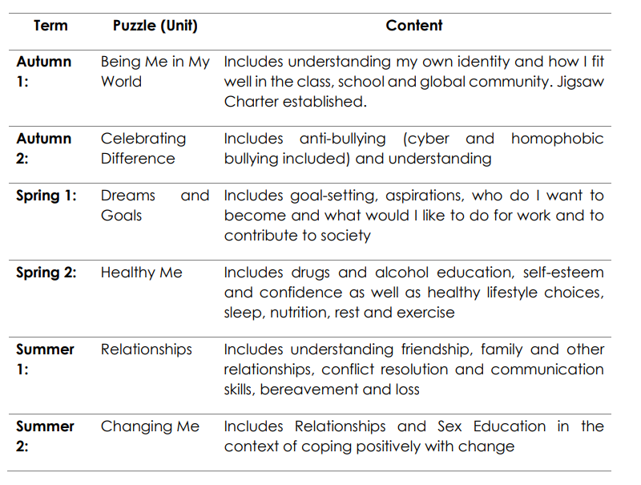

All areas of learning are taught within the context of family life taking care to ensure that there is no stigmatisation of children based on their home circumstances (families can include single parent families, LGBT parents, families headed by grandparents, adoptive parents, foster parents/carers amongst other structures) along with reflecting sensitively that some children may have a different structure of support around them (for example: looked after children or young carers).

Jigsaw RSE Content
4-5  5-6  6-7  7-8  8-9  9-10  10-11 | life; making friends; falling out and making up; being a good friend; dealing with bullying; growing up -how have I changed from baby to now; bodies (NOT including names of sexual parts); respecting my body and looking after it e.g. personal hygiene.
 | Recognising bullying and how to deal with it; celebrating differences between people; making new friends; belonging to a family; being a good friend; physical contact preferences; people who help us; qualities as a friend and person; celebrating people who are special to me; life cycles – animal and human; changes in me; changes since being a baby; differences between female and male bodies (correct terminology: penis, vagina, testicles); respecting my body and understand which parts are private.
 | Assumptions and stereotypes about gender; understanding bullying; standing up for self and others; making new friends; gender diversity; celebrating difference and remaining friends; learning with others; group co-operation; different types of family; physical contact boundaries; friendship and conflict; secrets (including those that might worry us);trust and appreciation; expressing appreciation for special relationships; life cycles in nature; growing from young to old; increasing independence; differences in female and male bodies (correct terminology); assertiveness; appreciate that some parts of my body are private.
Seeing things from others’ perspectives; Families and their differences; family conflict and how to manage it (child-centred); witnessing bullying and how to solve it; homophobic bullying; recognising how words can be hurtful; giving and receiving compliments; respect for myself and others; healthy and safe choices; family roles and responsibilities; friendship and negotiation; keeping safe online and who to go to for help; being aware of how my choices affect
Others; awareness of how other children have different lives; expressing appreciation for family and friends; how babies grow; understanding a baby’s needs; outside body changes at puberty; inside body changes at puberty; family stereotypes.
 | Challenging assumptions; judging by appearance; accepting self and others; understanding influences; understanding bullying including the role of the bystander; problem-solving in relationships; identifying how special and unique everyone is; first impressions; working in a group; celebrating contributions of others; healthier friendships; group dynamics; assertiveness; peer pressure; celebrating inner strength; jealousy; love and loss; memories of loved ones; getting on and falling out; girlfriends and boyfriends; showing appreciation to people and animals; being unique; having a baby (simple explanation of conception); girls and puberty; boys and puberty; confidence in change; accepting change.
Cultural differences and how they can cause conflict; racism; rumours and name-calling; types of bullying; enjoying and respecting other cultures; body image; self-recognition and self-worth; building self-esteem; safer online communities; rights and responsibilities online; online gaming and gambling; reducing screen time; dangers of online grooming;
SMART internet safety rules; Self and body image; influence of online and media on body image; puberty for girls; puberty for boys; conception (including IVF); growing responsibility; coping with change.

Children’s universal rights; feeling welcome and valued; choices, consequences and rewards; group dynamics; democracy, having a voice; anti-social behaviour; role-modelling; perceptions of normality; understanding disability; understanding what transgender means; power struggles; understanding bullying; inclusion/exclusion; difference as conflict; difference as celebration; empathy; exploitation, including ‘county-lines’ and gang culture; love and loss; managing feelings; power and control; assertiveness; technology safety; responsibility with technology
use; self-image, body image; puberty and feelings; conception to birth; reflections about change; physical attraction; respect and consent; boyfriends/girlfriends; sexting.

The grid below shows specific RSE content for each year group
- Access to the RSE Curriculum for Pupils with SEND

Under the 2019 Equalities Act, it is imperative that those pupils who have Special
Educational Needs & Disabilities (SEND), must enjoy full and unrestricted access to
the RSE curriculum. The school and the teachers must be flexible and mindful of
tailoring content and teaching to meet the needs of all SEND children, regardless of
their developmental stage. This may require further work to be undertaken with a
pupil/group of pupils; consideration given to differentiation and if necessary the
school should deliver sessions on a one to one basis. It is worth noting that children
with SEND are more vulnerable to exploitation, bullying and other issues related to
their specific need(s).

We have incorporated a six week scheme of work using the NSPCC`s Speak Out Stay Safe programme. With the help of a mascot Buddy, the Speak out Stay Safe programme covers topics like bullying and abuse - without using any scary words or adult language. Children learn about the different types of abuse in a child-friendly and age appropriate way, so they can get help if or when they need it. It enables children to identify safe adults that they can talk to if they're ever worried about themselves or a friend. They learn about Childline, and how it can support them. The NSPCC’s ‘PANTS’ rules are shared with all pupils and can help those with
learning difficulties to understand how to stay safe:

• Privates are private;
• Always remember your body belongs to you;
• No means no;
• Talk about secrets that upset you;
• Speak up, someone can help.

Roles and Responsibilities

The Governing Board

The governing board will approve the PSHE & RSE policy, and hold the Executive Principal to account for its implementation.
The Governing Body has:

- appointed a member of staff to be responsible for Personal, Social and Health Education including Relationship and Sex Education;
- delegated powers and responsibilities to the Executive Principal to ensure all school personnel and stakeholders are aware of and comply with this policy;
- produced a policy outlining the rationale and organisation of the Relationships and Sex Education (RSE) programme;
- a duty to inform parents/carers of the policy;
- a duty to inform parents/carers of their right of withdrawing their child from part of the school’s RSE programme if they so wish [complying with the right to withdraw clause]
- responsibility for ensuring that the school complies with all equality legislation;
- responsibility for ensuring funding is in place to support this policy;
- make effective use of relevant research and information to improve this policy;
- responsibility for ensuring this policy and all policies are maintained and updated regularly;
- responsibility for ensuring all policies are made available to parents/carers;
- the responsibility of involving the School Council in:
  - organising surveys to gauge the thoughts of all pupils
- nominated a link governor to:
  - visit the school regularly;
  - work closely with the Executive Headteacher
  - ensure this policy and other linked policies are up to date;
  - ensure everyone connected with the school is aware of the policy;
  - attend training relating to this policy;
  - report to the wider Governing Board as appropriate;
  - annually report to the wider Governing Board on the success and development of this policy.
- responsibility for the effective implementation, monitoring and evaluation of this policy.

The Executive Headteacher and Head

The Executive Headteacher and Head are responsible for ensuring that RSE is taught consistently across the school, and for managing requests to withdraw pupils from [non-statutory/non-science] components of RSE (section 8).
The Executive Headteacher and Head will:
- implement the policy;
- ensure all school personnel, pupils and parents/carers are aware of and comply with this policy;
- work closely with the link governor and coordinator;
- provide leadership and vision in respect of equality;
- make effective use of relevant research and information to improve this policy;
- organise effective training for the teaching staff so that they can handle any difficult issues with sensitivity.
- monitor the effectiveness of this policy by:
  - learning walks and observations
  - planning and assessments
  - book scrutiny
  - pupil feedback in work
  - speaking with pupils, staff, parents, carers and governors
- annually report to the Governing Board on the success and development of this policy.

Staff

Staff are responsible for:
- Delivering RSE in a sensitive way.
- Modelling positive attitudes to RSE Monitoring progress.
- Responding to the needs of individual pupils.
- Responding appropriately to pupils whose parents wish them to be withdrawn from the [non- statutory/non-science] components of RSE.
- Comply with all aspects of this policy.
- Use a variety of teaching methods and resources to deliver the SRE programme.
- Implement the school’s equalities policy and schemes.
- Report and deal with all incidents of discrimination.
- Attend appropriate training sessions on equality.
- Report any concerns they have on any aspect of the school community.

Staff do not have the right to opt out of teaching RSE. Staff who have concerns about teaching RSE are encouraged to discuss this with the Head.

Pupils

Pupils are expected to take part fully in PSHE & RSE and, when discussing issues related to RSE, treat others with respect and sensitivity.
Pupils will:
- be aware of and comply with this policy;
- listen carefully to all instructions given by the teacher;
- be encouraged to ask questions in order to further develop their knowledge, skills and attitudes;
- ask for further help if they do not understand;
- treat others, their work and equipment with respect;
- support the school Code of Conduct and guidance necessary to ensure the smooth running of the school;
- liaise with the school council;
- take part in questionnaires and surveys

Parents/Carers

All parents/carers must:
- acknowledge that they have a primary role in their child’s PSHE & RSE programme;
- be fully aware of the school’s PSHE & RSE policy;
- ask any pertinent questions regarding their child’s sex education at the school;
- be aware of their rights of withdrawing their child from of the [non-statutory/non-science] RSE programme that we teach in this school.
- take part in periodic questionnaires/surveys conducted by the school;
- support the school Code of Conduct and guidance necessary to ensure smooth running of the school.

Right to Withdraw

“Parents have the right to request that their child be withdrawn from some or all of sex education delivered as part of statutory Relationships and Sex Education” DfE Guidance p.17.

Relationships Education will be taught in PSHE sessions. The Relationships Education, RSE, and Health Education (England) Regulations 2019 have made Relationships Education compulsory in all primary schools. Sex education is not compulsory in primary schools. Parents will not be able to withdraw their child from relationships education in primary school. Primary schools that choose to teach aspects of sex education which go beyond the national curriculum for science must allow parents a right to withdraw their child/ children.

At Whitehouse PRU, puberty is taught as a statutory requirement of Health Education and covered by our Jigsaw PSHE Programme in the ‘Changing Me’ Puzzle (unit). We conclude that sex education refers to Human Reproduction, and therefore inform parents of their right to request their child be withdrawn from the PSHE lessons that explicitly teach this i.e. the Jigsaw Changing Me:

Year 4, Lesson 2 (Having a baby)
Year 5, Lesson 4 (Conception)
Year 6, Lesson 4 (Conception, birth)
Year 5 & 6 Drop Down Events delivered by the School Nursing Team (Conception)

A copy of the PSHE and RSE Policy will be available on the school’s website and a paper copy can be obtained through the school office.

Our staff are committed to working with parents and carers as their support and engagement with RSE is integral to the effectiveness of the programme.
Parents’/carers’ views and concerns about RSE will be sought through communication between school and home.
Information events will be organised for the parents/carers of children of Key Stage 2 and they will be notified when particular aspects of sex and relationship education will
be taught. Parents and carers are given opportunities to view and discuss any sensitive materials with regard to sex and relationships.
We will communicate to parents about their right to withdraw their children (where conception is covered) and sensitively plan a replacement curriculum if necessary.
Withdrawal form in Appendix

Training and Monitoring

Staff are trained on the delivery of PSHE and RSE as part of their induction and it is included in our continuing professional development using National College and calendared INSET days.
The Executive Headteacher and Head will also invite visitors from outside the school, such as school nurses or health professionals, to provide support and training to staff teaching RSE.

The delivery of PSHE and RSE is monitored by Mrs D Kaye
Monitoring arrangements, such as planning scrutiny, learning walks will be calendared by the Head and Senior Leadership Team. Pupils’ development in PSHE and RSE is monitored by class teachers as part of our internal assessment systems.
This policy will be reviewed by Mrs D Kaye annually. At every review, the policy will be approved by Mrs L Broughton Chair of Governor and Senior Leadership Team.

Differentiation and SEN

The PSHE curriculum is written as a universal core curriculum provision for all children. Inclusivity is part of its philosophy. Teachers will need, as always, to tailor each lesson to meet the needs of the children in their classes. To support this differentiation, many lessons suggest creative learning activities that allow children to choose the media with which they work and give them scope to work to their full potential.

Safeguarding

Teachers need to be aware that sometimes disclosures may be made during these sessions; in which case, safeguarding procedures must be followed immediately. Sometimes it is clear that certain children may need time to talk one-to-one after the lesson finishes. It is important to allow the time and appropriate staffing for this to happen. If disclosures occur, the school’s safeguarding and disclosure policy is followed. All recordings to comply with the use of CPOMS.

Appendix
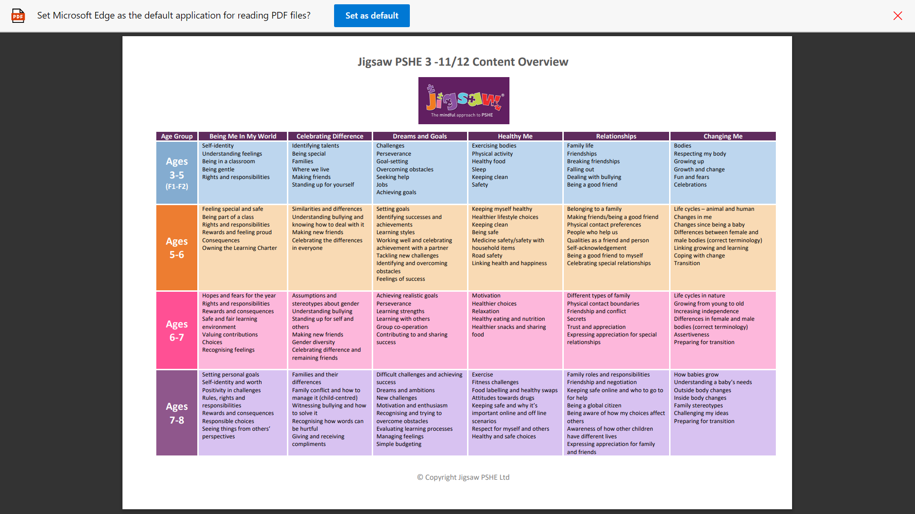
Curriculum Map

By the end of primary school pupils should know – DfE Guidance 2019

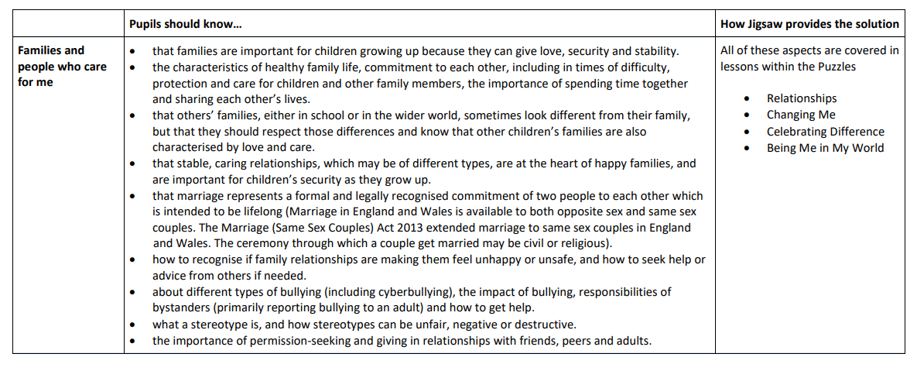

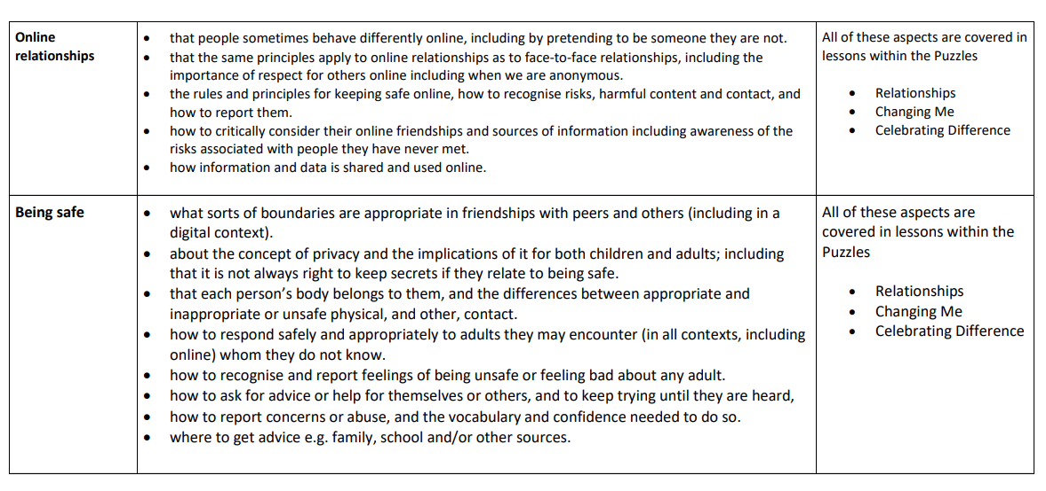

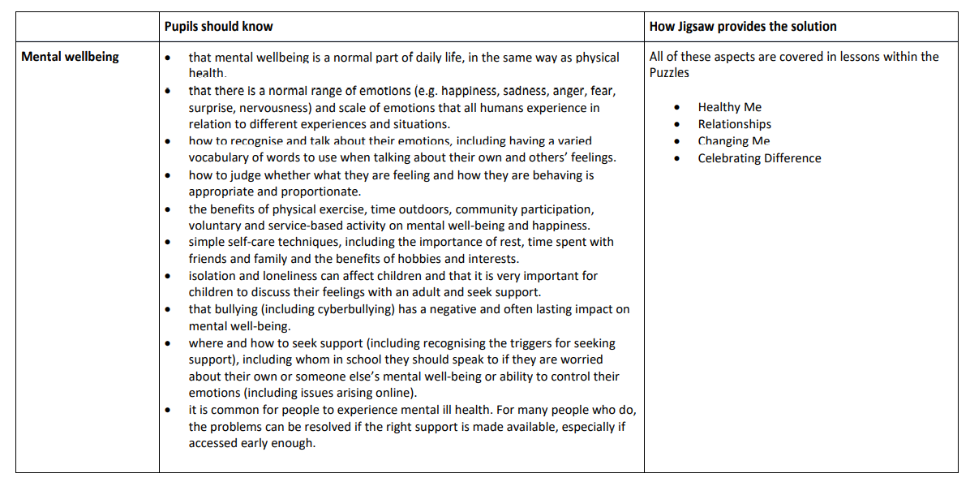

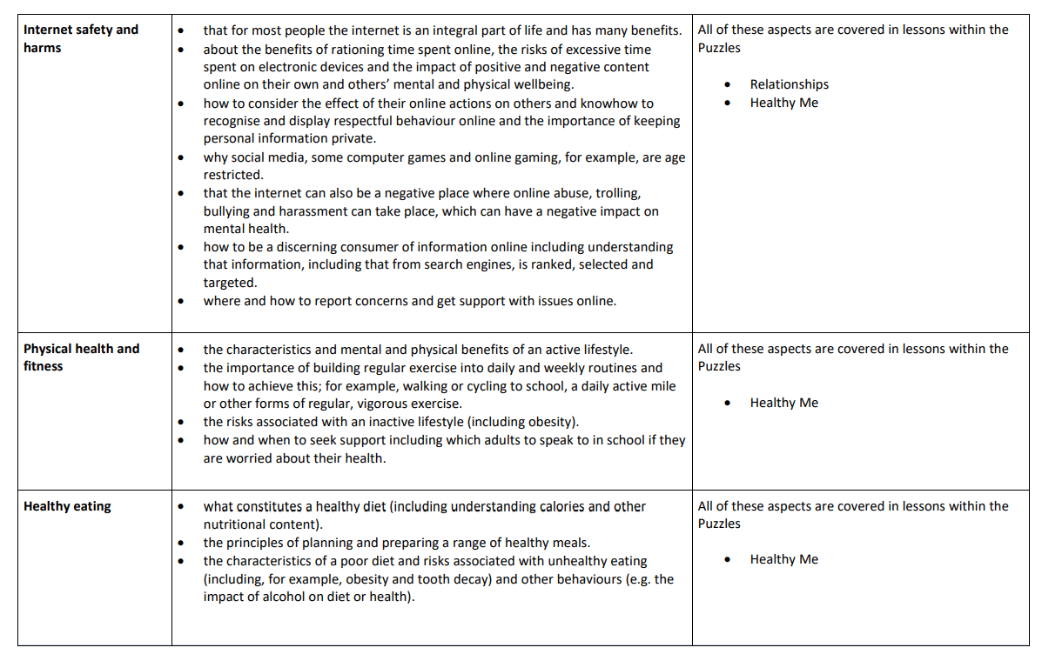
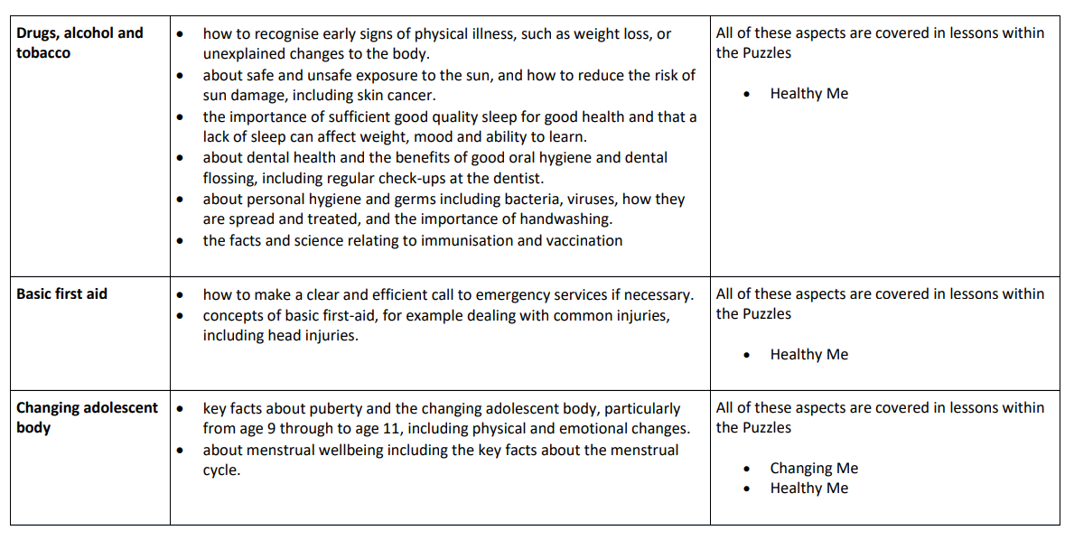

TO BE COMPLETED BY PARENTS
Name of child |  | Class
Name of parent |  | Date
Reason for withdrawing from sex education within relationships and sex education
Any other information you would like the school to consider
Parent signature
Withdrawal Form

