Whitehouse PRU

Attendance Policy

1 | Summary | Attendance Policy
2 | Responsible person | Claire Goodaire
3 | Accountable SLT member | Katie Troake
4 | Applies to | ☒All staff  ☐Support staff  ☐Teaching staff
5 | Who has overseen development of this policy | Claire Goodaire -Executive Headteacher  Laura Carr- Director of Safeguarding, Attendance, Risk and Welfare.
6 | Who has been consulted and recommended policy for approval | Governors
7 | Approved by and date
8 | Version number | V1.4
9 | Available on | Every | ☒Y  ☐N | Trust website  Academy website  SharePoint | ☐Y ☐N  ☒Y ☐N  ☒Y ☐N
10 | Related documents (if applicable)
11 | Disseminated to | ☒Trustees/governors  ☒All staff  ☒Support staff  ☒Teaching staff
12 | Date of implementation (when shared) | 8.7.24
13 | Consulted with recognised trade unions | ☐Y ☒N

Contents
1. Introduction
2. Legislation and guidance 3
3. Roles and responsibilities 4
4. Recording attendance 7
5. Authorised and unauthorised absence 9
6. Strategies for promoting attendance 12
7. Supporting pupils who are absent or returning to school 12
8. Attendance monitoring 14
9. Intervention Stratergies 16
10. Legal Intervention 16
11. Monitoring Arrangements………………………………………………………… 19

12. Links to other policies………………………………………………………………….19

Appendix 1: attendance codes 17

Introduction
This policy aims to show our commitment to meeting our obligations with regards to school attendance, including those laid out in the Department for Education’s (DfE’s) statutory guidance on working together to improve school attendance (applies from 19 August 2024), through our whole-school culture and ethos that values good attendance, including:
- Setting high expectations for the attendance and punctuality of all pupils
- Promoting good attendance and the benefits of good attendance
- Reducing absence, including persistent and severe absence
- Ensuring every pupil has access to the full-time education to which they are entitled
- Acting early to address patterns of absence
- Building strong relationships with families to make sure pupils have the support in place to attend school
We will also promote and support punctuality in attending lessons.

Venn sees attendance as more than just been physically present, but also playing an active part in the entire school community and Trust.
Our Trust believes the foundations of securing good attendance is that our schools are calm, orderly, safe, and supportive environments where all our pupils will want to be and ready to learn. We understand that there are times there can be barriers to good school attendance, and these can be complex in nature, but by building strong respectful relationships with both children and families, we are confident that all obstacles can be overcome.

Good school attendance is key to academic success.

2. Legislation and guidance
This policy is based on the Department for Education’s (DfE’s) statutory guidance on working together to improve school attendance (applies from 19 August 2024) and school attendance parental responsibility measures. The guidance is based on the following pieces of legislation, which set out the legal powers and duties that govern school attendance:
- Part 6 of the Education Act 1996
- Part 3 of the Education Act 2002
- Part 7 of the Education and Inspections Act 2006
- The Education (Pupil Registration) (England) Regulations 2006 (and 2010, 2011, 2013, and 2016 amendments)
- The Education (Penalty Notices) (England) (Amendment) Regulations 2013
It also refers to:

- School census guidance
- Keeping Children Safe in Education
- Mental health issues affecting a pupil's attendance: guidance for schools

3. Roles and responsibilities
3.1 The governing board
The governing board is responsible for:
- Setting high expectations of all school leaders, staff, pupils and parents
- Making sure school leaders fulfil expectations and statutory duties, including:
  - Making sure the school records attendance accurately in the register, and shares the required information with the DfE and local authority
  - Making sure the school works effectively with local partners to help remove barriers to attendance, and keeps them informed regarding specific pupils, where appropriate
- Recognising and promoting the importance of school attendance across the school’s policies and ethos
- Making sure the school’s attendance management processes are delivered effectively, and that consistent support is provided for pupils who need it most by prioritising staff and resources
- Making sure the school has high aspirations for all pupils, but adapts processes and support to pupils’ individual needs
- Regularly reviewing and challenging attendance data and helping school leaders focus improvement efforts on individual pupils or cohorts who need it most
- Working with school leaders to set goals or areas of focus for attendance and providing support and challenge
- Monitoring attendance figures for the whole school and repeatedly evaluating the effectiveness of the school’s processes and improvement efforts to make sure they are meeting pupils needs
- Where the school is struggling with attendance, working with school leaders to develop a comprehensive action plan to improve attendance
- Making sure all staff receive adequate training on attendance as part of the regular continued professional development offer, so that staff understand:
  - The importance of good attendance
  - That absence is almost always a symptom of wider issues
  - The school’s legal requirements for keeping registers
  - The school’s strategies and procedures for tracking, following up on and improving attendance, including working with partners and keeping them informed regarding specific pupils, where appropriate

- Making sure dedicated training is provided to staff with a specific attendance function in their role, including in interpreting and analysing attendance data
- Sharing effective practice on attendance management and improvement across schools]
- Holding the headteacher to account for the implementation of this policy

Terry Johnson, Governor and Trustee is our link Attendance partner.
3.2 The Head of School
The Head of School is responsible for:
- The implementation of this policy at the school
- Monitoring school-level absence data and reporting it to governors
- Supporting staff with monitoring the attendance of individual pupils
- Monitoring the impact of any implemented attendance strategies
- Issuing penalty notices, where necessary in consultation with the Executive Head.
- Working with the parents of pupils with special educational needs and/or disabilities (SEND) to develop specific support approaches for attendance for pupils with SEND, including where school transport is regularly being missed, and where pupils with SEND face in-school barriers
- Communicating with the local authority when a pupil with an education, health and care (EHC) plan has falling attendance, or where there are barriers to attendance that relate to the pupil’s needs
- Communicating the school’s high expectations for attendance and punctuality regularly to pupils and parents through all available channels
3.3 The Head of School and the attendance team are responsible for:
- Leading, championing and improving attendance across the school
- Setting a clear vision for improving and maintaining good attendance
- Evaluating and monitoring expectations and processes
- Having a strong grasp of absence data and oversight of absence data analysis
- Regularly monitoring and evaluating progress in attendance
- Establishing and maintaining effective systems for tackling absence, and making sure they are followed by all staff
- Liaising with pupils, parents/carers and external agencies, where needed
- Building close and productive relationships with parents to discuss and tackle attendance issues
- Creating intervention or reintegration plans in partnership with pupils and their parents/carers
- Delivering targeted intervention and support to pupils and families
The Attendance team consists of Jake Thompson, (Head of School Kelly Pullen (Safeguarding and Welfare Officer) and Chantelle Roberts (Attendance and Welfare Officer).
3.4 The attendance officer
The school attendance officer is responsible for:
- Monitoring and analysing attendance data (see section 7)
- Benchmarking attendance data to identify areas of focus for improvement
- Providing regular attendance reports to school staff and reporting concerns about attendance to the designated senior leader responsible for attendance, and the headteacher
- Working with education welfare officers to tackle persistent absence
- Advising the Head of School when to issue penalty notices
The attendance officer is Chantelle Roberts and can be contacted via chantelle.roberts@vennacademy.org

3.5 Registers
Attendance Officer is responsible for recording attendance for both morning and afternoon sessions daily, using the correct codes (see Appendix 1), and submitting this information, this needs to be completed by 9.15am and 12:00pm.
3.6 School admin staff
School admin staff will:
- Take calls from parents/carers about absence on a day-to-day basis and record it on Arbour
3.7 Parents
Where this policy refers to a parent, it refers to the adult the school and/or local authority decides is most appropriate to work with, including:
- All natural parents, whether they are married or not
- All those who have parental responsibility for a child or young person
- Those who have day-to-day responsibility for the child (i.e. lives with and looks after them)
Parents are expected to:
- Make sure their child attends every timetabled session on time
- Call the school to report their child’s absence before 9am on the day of the absence and each subsequent day of absence, and advise when they are expected to return
- Provide the school with 2 emergency contact numbers for their child, this will be collated on admissions.
- Ensure that, where possible, appointments for their child are made outside of the school day
- Keep to any attendance agreements that they make with the school and/or local authority
- Seek support, where necessary, for maintaining good attendance, by contacting Kelly Pullen or Chantelle Roberts who can be contacted via email.
Kelly.Pullen@vennacademy.org
Chantelle.Roberts@vennacademy.org
3.8 Pupils
Pupils are expected to:
- Attend every day
- Attend all planned timetable sessions

4. Recording attendance
4.1 Attendance register
We will keep an electronic attendance register, and place all pupils onto this register.
We will take our attendance register at the start of the first session of each school day and again in the afternoon if the child is expected to attend a full day. If attending half a day there will only be one mark. Marks will be completed using the appropriate national attendance and absence codes from the School Attendance (Pupil Registration) (England) Regulations 2024, whether every pupil is:
- Present
- Attending an approved off-site educational activity
- Absent
- Unable to attend due to exceptional circumstances

Any amendment to the attendance register will include:
- The original entry
- The amended entry
- The reason for the amendment
- The date on which the amendment was made
- The name and position of the person who made the amendment
See Appendix 1 for the DfE attendance codes.

We will also record:
- Whether the absence is authorised or not
- The nature of the activity, where a pupil is attending an approved educational activity
- The nature of circumstances, where a pupil is unable to attend due to exceptional circumstances
We will keep every entry on the attendance register for 6 years after the date on which the entry was made.

The school day starts between 08:20am and 9.15am and ends at 2:30pm every day except a Thursday, on a Thursday the school day ends at 1.30pm.
Pupils must arrive in school by 9.15am on each school day.
The register for the first session will be taken at 09:00am and will be kept open until 9.15am. The register for the afternoon will be taken at 12:00pm and will be kept open until 12:15pm.

Procedures for power or network failure
In the event of the school network fails, manual attendance registers will be used for both morning and afternoon registration. Completed registers will be returned to the school office and uploaded to the system once the problem has been resolved.

4.2 Unplanned absence
The pupil’s parent/carer must notify the school of the reason for the absence on the first day of an unplanned absence by 9am or as soon as practically possible, by calling the school office staff, who can be contacted via 01482 303300.

We will mark absence due to physical or mental illness as authorised, unless the school has a genuine concern about the authenticity of the illness.

Where the absence is longer than 3 days, or there are doubts about the authenticity of the illness, the school will ask for medical evidence, such as a doctor’s note, prescription, appointment card or other appropriate form of evidence. We will not ask for medical evidence unnecessarily.

If the school is not satisfied about the authenticity of the illness, the absence will be recorded as unauthorised and parents will be notified of this in advance.

4.3 Planned absence
Attending a medical or dental appointment will be counted as authorised as long as the pupil’s parent notifies the school in advance of the appointment. This can be done by calling the Office or emailing the Head of School or Attendance team.

However, we encourage parents to make medical and dental appointments out of school hours where possible. Where this is not possible, the pupil should be out of school for the minimum amount of time necessary.

The pupil’s parent must also apply for other types of term-time absence as far in advance as possible of the requested absence. Go to section 5 to find out which term-time absences the school can authorise.

Parents will be aware of these dates and should give the school written notification in advance.

Part-time timetables
All compulsory aged children are entitled to a full-time education suitable to their age, aptitude, and special educational needs. Only in an exceptional circumstance, where it is the pupil’s best interest, would a part-time timetable be considered. This intervention should not be used as an approach to manage pupil’s behaviour.

If a part time timetable is authorised, the school must notify both the Trust’s Director of Safeguarding plus the respective Local Authority. A period when the child is not in school, must be recorded as an authorised absence (Code C2).

All schools will ensure that the Designated Safeguarding Lead has been consulted, a risk assessment carried out and suitably robust arrangements are in place to ensure the ongoing safeguarding of any pupil on a part time timetable.

All part time timetables are regularly reviewed, and are only used for limited periods, after which the pupil is expected to return to full time.

Special Educational Needs & Disabilities (SEND)
The school will ensure ‘reasonable adjustments’ are made for pupils with additional needs (defined as those with a ‘physical or mental impairment which has a substantial and long-term adverse effect on that person’s ability to carry out normal day to day activities’). This may include changes to the physical environment, curriculum or the way information is provided, as well as providing auxiliary aids and equipment, or tailored services. The school recognises that some pupils with additional needs may need support to attend regularly and that, for some pupils, they may have more absence due to their disability, for example due to attending medical appointments. The school will ensure that pupils are not penalised for absence related to their additional needs and will support access support from external agencies where appropriate.

Alternative Provision
Schools are responsible for the safeguarding and welfare of pupils educated off-site. Where this is the case, they will have reciprocal arrangements in place with the alternative provider to ascertain attendance information. This should be provided daily. All unexplained and unexpected absences will be followed up by the home school in a swift and timely manner.

The school will use the appropriate code (B) to indicate that the child is accessing alternative provision, thus demonstrating the school has confirmed that the education is supervised, and appropriate measures are in place to safeguard children.

Bullying/Harassment
Our schools do not condone bullying or harassment by pupils, members of staff or parents.
If any form of this behaviour occurs, it will be dealt with as a very serious matter. No one should feel they cannot attend school for fear of being bullied or harassed.

Child Criminal Exploitation and Child Sexual Exploitation
Children who go missing or are persistently absent from school may be an indicator of exploitation, especially if other key factors are also present.
Some other potential signs of criminal or sexual exploitation are:
• missing from home and /or being found out-of-area
• unexplained acquisition of money, clothes, or mobile phones
• excessive receipt of texts / phone calls and/or having multiple handsets
• relationships with controlling / older individuals or groups
• leaving home / care without explanation
• suspicion of physical or sexual assault / unexplained injuries
• parental concerns
• carrying weapons
• significant decline in school results / performance
• gang association or isolation from peers or social networks
• self-harm or significant changes in emotional well-being.

At Venn we monitor absenteeism daily to ascertain pupil’s whereabouts to ensure they are safe from harm. We will work endlessly with all statutory and non-statutory agencies, including parents/carer to protect any child at risk or at possibly risk of this form of abuse.
If a class teacher or tutor is concerned about a child who is regularly absent and presents with any of the signs listed above, they must inform the Designated Safeguarding Lead immediately, as per the school’s Child Protection policy.

Young carers
The school recognises that pupils who are Young Carers may have caring responsibilities that impact on their punctuality and/or attendance. Where this is the case, the school will work with the pupil and family to encourage them to access appropriate support, including direct support from Young Carers and any other support the pupil and family may need; the school will also provide support in school where appropriate.

4.4 Following up on unexplained absences
Where any pupil we expect to attend school does not attend, or stops attending without reason, Whitehouse PRU will:
- Call the parent/carer on the morning of the first day of absence to ascertain the reason. If no contact can be made the emergency contacts on the admissions forms will be called. If no contact can be made the school will conduct a home visit.
- Pupils seen - Identify if the reason for absence is to authorise or not.
- Identify the correct attendance code to use and input it as soon as the reason is offered.
- Call the parent/carer on each day that the absence continues. If the absence continues the school will organise a meeting, all stakeholders will be invited and there may be support and involved needed from the LA following this policy.

- If no text is received for a child CLA, a further home visit will be carried out, if there is still no answer for the unexplained absence it will be reported to the non-emergency Police and all stakeholders, e.g. Social Care, Dual Registered School.

4.5 Following up on absences.
- If a pupil is absent from school due to an authorised reason, e.g. illness. A home visit will still be carried out every 3 days. Whitehouse PRU staff team will need to see the child to follow our safeguarding procedures, even if this is a wave through the window!
- If a child has an EHCP, is Child Protection, Child in Need or is CLA the child will be visited daily where possible and when agreed with the Senior Leadership team.
4.6 Lateness and punctuality
A pupil who arrives late without a valid reason, e.g. transport will receive a late mark.

- Before the register has closed will be marked as late, using the appropriate code
- After the register has closed will be marked as absent, using the appropriate code
- Where relevant, report the unexplained absence to the pupil’s youth offending team officer
- Where appropriate, offer support to the pupil and/or their parents to improve attendance
- Identify whether the pupil needs support from wider partners, as quickly as possible, and make the necessary referrals
- Where support is not appropriate, not successful, or not engaged with: [issue a notice to improve, penalty notice or other legal intervention (see section 5.2 below), as appropriate]
4.7 Reporting to parents
Whitehouse PRU reports half termly to parents/carers. This is formally written up in end of Term reports.

5. Authorised and unauthorised absence
5.1 Approval for term-time absence
The Head of School will allow pupils to be absent from the school site for certain educational activities, or to attend other schools or settings.
The Head of School will only grant a leave of absence to a pupil during term time if the request meets the specific circumstances set out in the 2024 school attendance regulations. These circumstances are:
- Taking part in a regulated performance, or regulated employment abroad
- Attending an interview
- Study leave
- A temporary, time-limited part-time timetable
- Exceptional circumstances
A leave of absence is granted at the head of school’s discretion, including the length of time the pupil is authorised to be absent for.

Exceptional Circumstances at Whitehouse PRU refers to rare, significant, and unforeseen situations that warrant a pupil’s authorised leave of absence. These circumstances are typically beyond the pupil’s or their family's control and may include, but are not limited to:
- Medical Emergencies: Serious illness or injury requiring immediate and/or ongoing medical attention that cannot be scheduled outside of school hours.
- Bereavement: The death of a close family member or loved one, necessitating time off for funeral arrangements and grieving.
- Family Crisis: Critical situations within the family unit, such as severe illness of a family member, divorce proceedings, or other significant personal matters requiring the student's presence.
- Legal Obligations: Mandatory court appearances, immigration proceedings, or other legal matters that cannot be rescheduled.
- Unavoidable Transportation Issues: Significant disruptions in travel due to unforeseen events such as natural disasters or severe weather conditions.
- Other Compelling Reasons: Unique or extraordinary events that are assessed on a case-by-case basis by the school's administration.
For a leave of absence to be authorised under exceptional circumstances, appropriate documentation and a formal request must be submitted by completing the Exceptional Circumstanced Form (See appendix) and return to the Head of School. Any request should be submitted as soon as it is anticipated and, where possible, at least 4 weeks before the absence. The Head of School may require evidence to support any request for leave of absence.

Leave of absence will not be granted for a pupil to take part in protest activity during school hours.

As a leave of absence will only be granted in exceptional circumstances, it is unlikely a leave of absence will be granted for the purposes of a family holiday.

The school considers each application for term-time absence individually, taking into account the specific facts, circumstances and relevant background context behind the request.

Other valid reasons for authorised absence include (but are not limited to):
- Illness (including mental-health illness) and medical/dental appointments (see sections 4.2 and 4.3 for more detail)
- Religious observance – where the day is exclusively set apart for religious observance by the religious body to which the pupil’s parent(s) belong(s). If necessary, the school will seek advice from the parent’s religious body to confirm whether the day is set apart
- Parent(s) travelling for occupational purposes – this covers Roma, English and Welsh gypsies, Irish and Scottish travellers, showmen (fairground people) and circus people, bargees (occupational boat dwellers) and new travellers. Absence may be authorised only when a traveller family is known to be travelling for occupational purposes and has agreed this with the school, but it is not known whether the pupil is attending educational provision
- If the pupil is currently suspended or excluded from school (and no alternative provision has been made)
Other reasons the school may allow a pupil to be absent from the school site, which are not classified as absences, include (but are not limited to):
- Attending an offsite approved educational activity, sporting activity or visit or trip arranged by the school
- Attending another school at which the pupil is also registered (dual registration)
- Attending provision arranged by the local authority
- Attending work experience
- If there is any other unavoidable cause for the pupil not to attend school, such as disruption to travel caused by an emergency, a lack of access arrangements, or because the school premises are closed
5.2 Sanctions
Our school will make use of the full range of potential sanctions – including, but not limited to, those listed below – to tackle poor attendance. Decisions will be made on an individual, case-by-case basis.

Penalty notices
The Head of School (or someone authorised by them), local authority or the police can fine parents for the unauthorised absence of their child from school, where the child is of compulsory school age, by issuing a penalty notice.

If the school issues a penalty notice, it will check with the local authority before doing so.

Before issuing a penalty notice, the school will consider the individual case, including:
- Whether the national threshold for considering a penalty notice has been met (10 sessions of unauthorised absence in a rolling period of 10 school weeks)
- Whether a penalty notice is the best available tool to improve attendance for that pupil
- Whether further support, a notice to improve or another legal intervention would be a more appropriate solution
- Whether any obligations that the school has under the Equality Act 2010 make issuing a penalty notice inappropriate
A penalty notice may also be issued where parents allow their child to be present in a public place during school hours without reasonable justification, during the first 5 days of a suspension or exclusion (where the school has notified the parents that the pupil must not be present in a public place on that day).

Each parent of who has the day to day care who is liable for the pupil’s offence(s) can be issued with a penalty notice, but this will usually only be the parent/parents who allowed the absence.

The payment must be made directly to the local authority, regardless of who issues the notice. If the payment has not been made after 28 days, the local authority can decide whether to prosecute or withdraw the notice.

If issued with a first penalty notice, the parent must pay £80 within 21 days, or £160 within 28 days.

If a second penalty notice is issued to the same parent in respect of the same pupil, the parent must pay £160 if paid within 28 days.

A third penalty notice cannot be issued to the same parent in respect of the same child within 3 years of the date of the issue of the first penalty notice. In a case where the national threshold is met for a third time within those 3 years, alternative action will be taken instead.

Notices to improve
If the national threshold has been met and support is appropriate, but parents do not engage with offers of support, the school may offer a notice to improve to give parents a final chance to engage with support.

Notices to improve will be issued in line with processes set out in the local code of conduct for the local authority area in which the pupil attends school.

They will include:
- Details of the pupil’s attendance record and of the offences
- The benefits of regular attendance and the duty of parents under section 7 of the Education Act 1996
- Details of the support provided so far
- Opportunities for further support, or to access previously provided support that was not engaged with
- A clear warning that a penalty notice may be issued if attendance doesn’t improve within the improvement period, along with details of what sufficient improvement looks like, which will be decided on a case-by-case basis
- A clear timeframe of between 3 and 6 weeks for the improvement period
- The grounds on which a penalty notice may be issued before the end of the improvement period

6. Strategies for promoting attendance
The school’s strategies for rewarding and improving attendance include individual rewards and certificates for 100% attendance and improved attendance as well as group awards. Improved attendance is also celebrated in weekly assemblies and postcards are sent home to families.

7. Supporting pupils who are absent or returning to school
7.1 Pupils absent due to complex barriers to attendance
Improving attendance for pupils facing complex barriers, particularly in a medical setting relies on all stakeholders having a holistic and collaborative approach. Whitehouse PRU works closely with families to address health-related obstacles by maintaining open lines of communication and creating individualised health support plans tailored to each pupil’s medical needs. Strategies to remove in-school barriers include providing a flexible curriculum that accommodates medical appointments and recovery periods, integrating therapeutic support, and ensuring a nurturing and inclusive environment. Whitehouse PRU staff, including healthcare professionals and educators, collaborate to monitor and adapt these plans to suit evolving needs. Additionally, Whitehouse PRU connects families with external health services and support networks, empowering them to better manage their child's health and educational journey. This comprehensive support system helps mitigate the impact of medical issues on attendance, promoting consistent engagement and academic progress.
7.2 Pupils absent due to mental or physical ill health or SEND
Whitehouse PRU demonstrates a comprehensive approach to supporting students absent due to mental or physical ill health or SEND.

Whitehouse PRU prioritises early intervention by advising and engaging with parents/carers as soon as attendance concerns arise. They treat each case individually, recognising the unique needs of students with SEND or health issues. The school tends to these needs through a range of in-house support mechanisms, including the Barnardos WRAP (Wellness Recovery Action Plan) programme This programme nurture students' emotional well-being and resilience, crucial for maintaining good attendance.

Whitehouse PRU also dedicates resources to external support, making referrals to relevant mental health services when necessary. This multi-agency approach ensures Pupils receive comprehensive care tailored to their specific needs.

A key aspect of their support strategy is the explicit teaching of Executive Functioning skills. This is particularly important for students with SEND or mental health challenges, as these skills are crucial for self-regulation, organisation, and time management. By developing these skills, pupils are better equipped to manage their health conditions, cope with academic demands, and maintain consistent attendance.

The Centre's holistic approach, combining in-house support, external referrals, and skill development, demonstrates their commitment to supporting all students, regardless of their health or SEND status, in maintaining optimal attendance and engagement with education.
Sources:
- Working together to improve school attendance (DfE, 2023)
- Summary of responsibilities where a mental health issue is affecting attendance (DfE, 2023)
Where a pupil has an education health and care (EHC) plan and their attendance falls, or the school becomes aware of barriers to attendance that related to the pupil’s needs, the school will inform the local authority.
7.3 Pupils returning to school after a lengthy or unavoidable period of absence
Whitehouse PRU supports a child returning to the setting after a long period of absence through a carefully structured reintegration plan. This plan begins with a thorough assessment of the child's current medical, emotional, and academic needs, conducted in collaboration with healthcare professionals, the child's family, and previous educators. Whitehouse PRU creates a personalised schedule that gradually increases attendance, allowing the child to acclimate at a comfortable pace. Providing one-on-one support from a designated member of staff or a Life Coach to help the pupil navigate any anxiety or stress related to returning. In-class adaptations, such as modified timetables, ensures the pupil can engage without feeling overwhelmed. Additionally, peer support programs can foster a sense of belonging and community. Regular meetings will be organised with the family to keep them informed and involved, ensuring any emerging issues are promptly addressed. By offering a nurturing and adaptive environment, Whitehouse PRU facilitates a smooth transition back to regular attendance and ongoing academic success.

8. Attendance monitoring

Whitehouse PRU meticulously monitors attendance using the Arbor, a Whitehouse PRU to record daily attendance with precision, noting specific reasons for absences and identifying trends over time. Arbor provides real-time data, enabling staff to quickly detect any emerging attendance issues and intervene promptly. Arbor also offers customisable reports, which can be used during regular review meetings with families and healthcare providers to discuss the child's progress and address any barriers to attendance.

8.1 Monitoring attendance
The school will monitor attendance and absence data (including punctuality) half-termly, termly and yearly across the school and at an individual pupil, year group and cohort level.

Specific pupil information will be shared with the DfE on request.
The school has granted the DfE access to its management information system so the data can be accessed regularly and securely.
Data will be collected each term and published at national and local authority level through the DfE's school absence national statistics releases. The underlying school-level absence data is published alongside the national statistics.
The school will benchmark its attendance data at whole school, year group and cohort level against local, regional, and national levels to identify areas of focus for improvement, and share this with the governing board.
8.2 Analysing attendance
The school will:
- Analyse attendance and absence data regularly to identify pupils, groups or cohorts that need additional support with their attendance, and
- Identify pupils whose absences may be a cause for concern, especially those who demonstrate patterns of persistent or severe absence
- Conduct thorough analysis of half-termly, termly, and full-year data to identify patterns and trends
- Look at historic and emerging patterns of attendance and absence, and then develop strategies to address these patterns
8.3 Using data to improve attendance
Whitehouse PRU will:
- Develop targeted actions to address patterns of absence (of all severities) of individual pupils, groups or cohorts that it has identified via data analysis
- Provide targeted support to the pupils it has identified whose absences may be a cause for concern, especially those who demonstrate patterns of persistent or severed absence, and their families (see section 8.4 below)
- Provide regular attendance reports to Class Tutors, to facilitate discussions with pupils and families, and to the governing board and school leaders (including the SENCO, designated safeguarding lead and pupil premium lead)
- Use data to monitor and evaluate the impact of any interventions put in place in order to modify them and inform future strategies
- Share information and work collaboratively with other schools in the area, local authorities and other partners where a pupil’s absence is at risk of becoming persistent or severe, including keeping them informed regarding specific pupils, where appropriate
8.4 Reducing persistent and severe absence
Persistent absence is where a pupil misses 10% or more of school, and severe absence is where a pupil misses 50% or more of school. Reducing persistent and severe absence is central to the school’s strategy for improving attendance.
The school will:
- Use attendance data to find patterns and trends of persistent and severe absence
- Consider potential safeguarding issues and, where suspected or present, address them in line with Keeping Children Safe in Education
- Hold regular meetings with the parents of pupils who the school (and/or local authority) considers to be vulnerable or at risk of persistent or severe absence, or who are persistently or severely absent, to:
  - Discuss attendance and engagement at school
  - Listen, and understand barriers to attendance
  - Explain the help that is available
  - Explain the potential consequences of, and sanctions for, persistent and severe absence
  - Review any existing actions or interventions
- Provide access to wider support services to remove the barriers to attendance, in conjunction with the local authority, where relevant
- Consider alternative support that could be put in place to remove any barriers to attendance and re-engage these pupils. In doing so, the school will sensitively consider some of the reasons for absence
- Implement sanctions, where necessary (see section 5.2, above)
- Letters will be sent home, and meetings will be organised with the attendance team and also the Head of the School.

9-Intervention strategies
- Attendance is a key priority for all our schools which is actively monitored to ensure we are providing the right support at the right time for any pupil who may be encountering barriers to good attendance.
- We treat every pupil individually and understand that each case may take a different route depending on the barriers, needs of the family and any other circumstances which may be impacting on regular attendance.
- Our approaches are supportive and use legal interventions as a last resort.
- Below is the basis of our intervention pathway but schools should use their professional judgement at each stage and consider all mitigating factors.

97.5 = 1 week ( 5 days) missed school
100- 97.5%
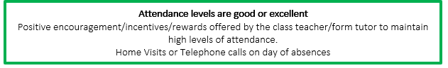

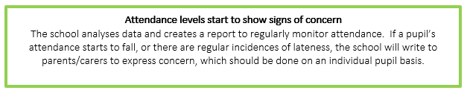
97.4 - 95%
95.4% = 2 weeks (10 days) missed school
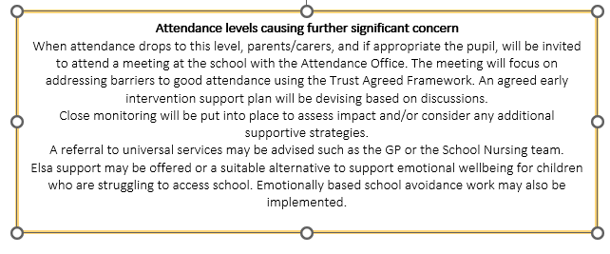
92.5% = 2 weeks, 4 days (14 days) missed school
94.9 -92.5%
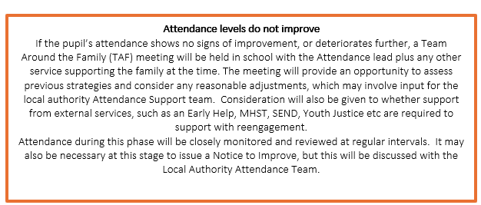
92 – 90%
90% = 3 weeks, 4 days (19 days) missed school

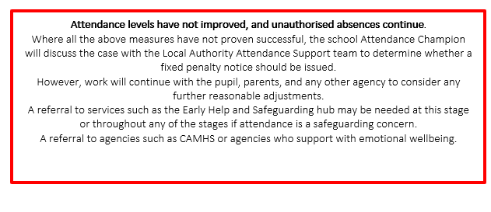
89.9 – 85%
85% = 5 weeks, 4 days (29 days) missed school

10-Legal intervention
Our schools will endeavour to work with families to prevent any legal action being taken. We will always ensure that sufficient time is given to allow any strategy the opportunity to be successful. However, in situation where no improvements are made, despite best efforts, or there is a lack of engagement, the school will consider using legal interventions before proceeding to penalty notices or prosecutions.

Attendance Contracts | Attendance Contract is a formal written agreement between a parent and either the school or local authority to address irregular attendance at school or alternative provision. An attendance contract is not legally binding but allows a more formal route to secure engagement with support where a voluntary early help plan has not worked or is not deemed appropriate. An attendance contract is not a punitive tool, it is intended to provide support and offer an alternative to prosecution. Parents cannot be compelled to enter an attendance contract, and they cannot be agreed in a parent’s absence.  There is no obligation on the school or local authority to offer an attendance contract, and it may not be appropriate in every instance, but an attendance contract should always be explored before moving forward to an education supervision order or prosecution.
Notice to improve | A Notice to Improve is a final opportunity for a parent to engage in support and improve attendance before a penalty notice is issued. If the national threshold has been met and support is appropriate but offers of support have not been engaged with by the parent or have not worked, a Notice to Improve should usually be sent to give parents a final chance to engage in support.  Notice to Improve are issued in line with processes set out in the Local Code of Conduct for the local authority area in which the pupil attends school.
Penalty Notice | Penalty notices are issued to parents as an alternative to prosecution where they have failed to ensure that their child of compulsory school age regularly attends the school where they are registered.  The threshold for considering a penalty notice is 10 sessions (5 days) of unauthorised absence in a rolling period of 10 school weeks. This can be met with any combination of unauthorised absence (e.g. 4 sessions of holiday taken in term time plus 6 sessions of arriving late after the register closes all within 10 school weeks) or can be consecutive (e.g. 10 sessions of holiday in one week). The 10 school weeks can also span different terms or school years. (e.g. 2 sessions of unauthorised absence in the Summer Term and a further 8 within the Autumn Term).  Only two penalty notices can be issued to same parent in respect of the same child within a 3-year rolling period. *
Attendance Prosecution | Prosecution in the Magistrates Court is the last resort where all other voluntary and formal support or legal intervention has failed or where support has been deemed inappropriate in the circumstances of the individual case. Where it is decided to pursue prosecution, only local authorities can prosecute parents.

*The first penalty notice issued will be charged at £160 if paid within 28 days but reduced to £80 if paid within 21 days. A second penalty notice issued to the same parent in respect of the same pupil is charged at a flat rate of £160. A third penalty notice cannot be issued to the same parent in respect of the same pupil within 3 years of the date of issues of the first. In these circumstances alternative action may be taken, including other attendance legal interventions, or prosecution.

11. Monitoring arrangements
This policy will be reviewed as guidance from the local authority and/or DfE is updated, and as a minimum once a year by Jake Thompson Head of School and Laura Carr Director of Safeguarding, Attendance, Risk and Welfare. The policy will be approved by the full governing board.

12. Links with other policies

This policy links to the following policies:

- Child protection and safeguarding policy
- Behaviour policy
- Data Protection
- Supporting children with medical needs
- Special Educational needs and disability

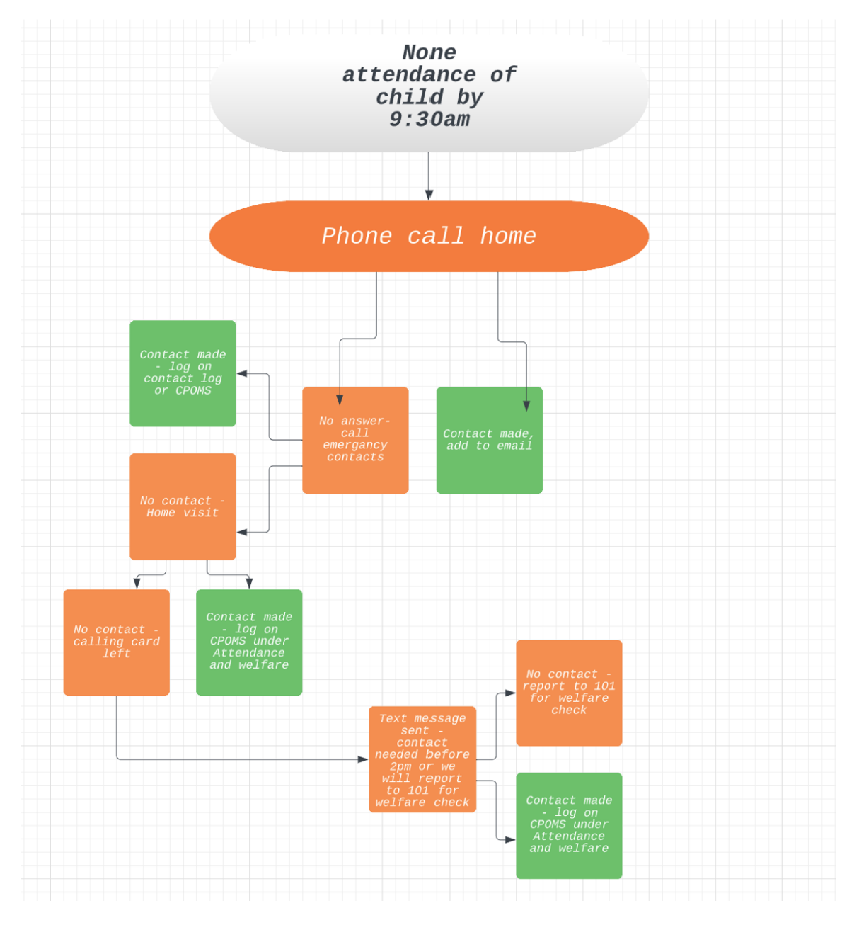

Appendix 1: attendance codes
The following codes are taken from the DfE’s guidance on school attendance.

Code | Definition | Scenario
/ | Present (am) | Pupil is present at morning registration
\ | Present (pm) | Pupil is present at afternoon registration
L | Late arrival | Pupil arrives late before register has closed
Attending a place other than the school
K | Attending education provision arranged by the local authority | Pupil is attending a place other than a school at which they are registered, for educational provision arranged by the local authority
V | Attending an educational visit or trip | Pupil is on an educational visit/trip organised or approved by the school
P | Participating in a sporting activity | Pupil is participating in a supervised sporting activity approved by the school
W | Attending work experience | Pupil is on an approved work experience placement
B | Attending any other approved educational activity | Pupil is attending a place for an approved educational activity that is not a sporting activity or work experience
D | Dual registered | Pupil is attending a session at another setting where they are also registered
Absent – leave of absence
C1 | Participating in a regulated performance or undertaking regulated employment abroad | Pupil is undertaking employment (paid or unpaid) during school hours, approved by the school
M | Medical/dental appointment | Pupil is at a medical or dental appointment
J1 | Interview | Pupil has an interview with a prospective employer/educational establishment
S | Study leave | Pupil has been granted leave of absence to study for a public examination
X | Not required to be in school | Pupil of non-compulsory school age is not required to attend
C2 | Part-time timetable | Pupil is not in school due to having a part-time timetable
C | Exceptional circumstances | Pupil has been granted a leave of absence due to exceptional circumstances
Absent – other authorised reasons
T | Parent travelling for occupational purposes | Pupil is a ‘mobile child’ who is travelling with their parent(s) who are travelling for occupational purposes
R | Religious observance | Pupil is taking part in a day of religious observance
I | Illness (not medical or dental appointment) | Pupil is unable to attend due to illness (either related to physical or mental health)
E | Suspended or excluded | Pupil has been suspended or excluded from school and no alternative provision has been made
Absent – unable to attend school because of unavoidable cause
Q | Lack of access arrangements | Pupil is unable to attend school because the  local authority has failed to make access arrangements to enable attendance at school
Y1 | Transport not available | Pupil is unable to attend because school is not within walking distance of their home and the transport normally provided is not available
Y2 | Widespread disruption to travel | Pupil is unable to attend because of widespread disruption to travel caused by a local, national or international emergency
Y3 | Part of school premises closed | Pupil is unable to attend because they cannot practicably be accommodated in the part of the premises that remains open
Y4 | Whole school site unexpectedly closed | Every pupil absent as the school is closed unexpectedly (e.g. due to adverse weather)
Y5 | Criminal justice detention | Pupil is unable to attend as they are:  - In police detention  - Remanded to youth detention, awaiting trial or sentencing, or  - Detained under a sentence of detention
Y6 | Public health guidance or law | Pupil’s travel to or attendance at the school would be prohibited under public health guidance or law
Y7 | Any other unavoidable cause | To be used where an unavoidable cause is not covered by the other codes
Absent – unauthorised absence
G | Holiday not granted by the school | Pupil is absent for the purpose of a holiday, not approved by the school
N | Reason for absence not yet established | Reason for absence has not been established before the register closes
O | Absent in other or unknown circumstances | No reason for absence has been established, or the school isn’t satisfied that the reason given would be recorded using one of the codes for authorised absence
U | Arrived in school after registration closed | Pupil has arrived late, after the register has closed but before the end of session
Administrative codes
Z | Prospective pupil not on admission register | Pupil has not joined school yet but has been registered
# | Planned whole-school closure | Whole-school closures that are known and planned in advance, including school holidays

Appendix 2
Absence from School for Exceptional Circumstances Request Form

Child(ren)’s Name(s) | DOB | School Name | Year/Class
Please add all children to one form
Parental Full Name | Parents Tel | Parental DOB

Home Address of parent(s) responsible for this absence | Email address

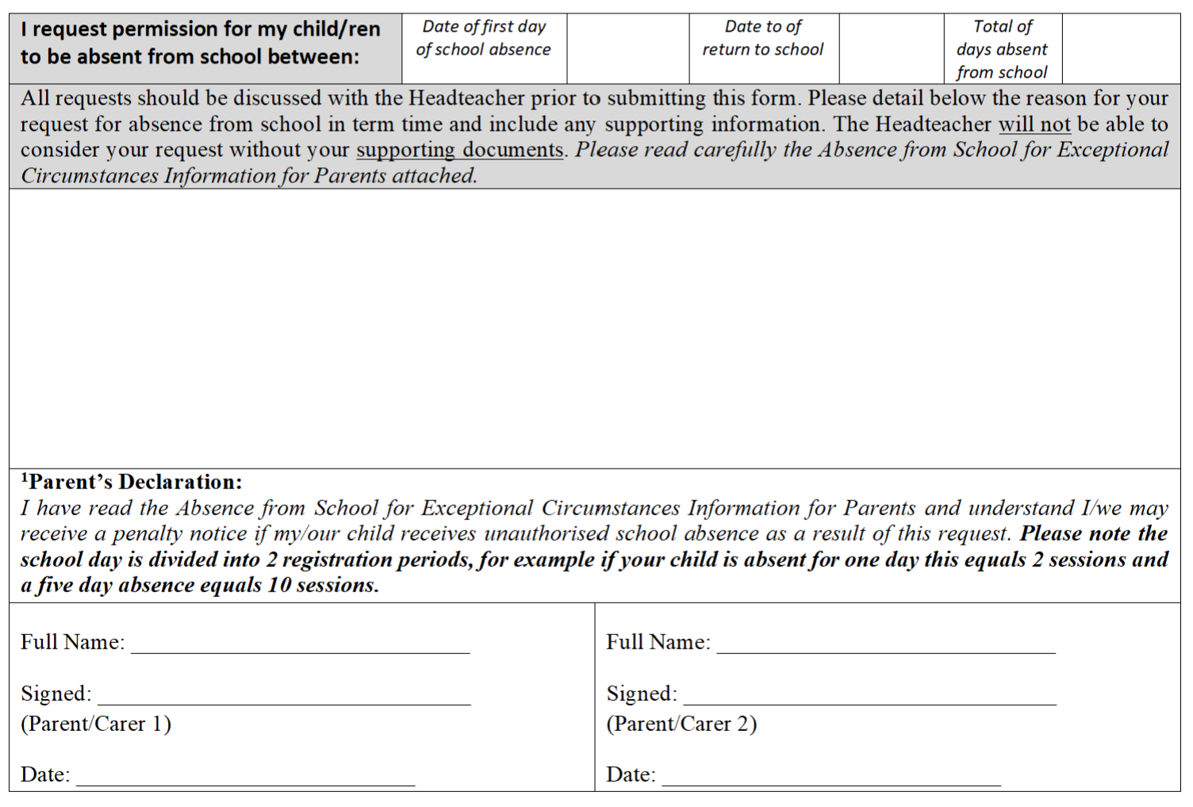

Please note:
- We advise that you do not plan for your child to be absent from school without gaining prior agreement from their school first. Headteachers cannot retrospectively authorise absence from school under any circumstance.
- Any disagreement between estranged parents should be resolved prior to submitting this request to your child’s school.

For School Use Only

The school has considered your request for leave of absence and your child’s absences will be recorded as follows: -
Number of Authorised Sessions: |  | Number of Unauthorised Sessions: |  | Number of Unauthorised sessions to date:

Signed:  Position: | Date:

Original signed and completed forms to be retained with pupil’s records.

Copy should be returned to the parent/carer of the pupil to confirm authorised or unauthorised absence prior to the intended absence period.

Absence from School for Exceptional Circumstances
Information for Parents

There is no longer a provision in law for Headteachers to authorise an absence for the purpose of a term time holiday.

You are required under the Education Act (1996) to ensure your child attends school regularly. This has been defined by the Supreme Court as ‘in accordance with the rules prescribed by the school’ meaning attending every occasion available unless authorised by the Head Teacher. There is, however, a discretionary power held by Headteachers to authorise absence in exceptional circumstances. Please note this is not an entitlement. The Headteacher will only authorise absence in line with the East Riding Behaviour & Attendance Partnership ‘Absence from School for Exceptional Circumstances’ Policy. Headteachers will not authorise absences if they believe it is to the detriment of a child’s education. Please note that supporting documents to aid decision making must be submitted at the time of your request for absence.

Any unauthorised absence will be recorded on your child’s attendance records. This may result in legal proceedings against you, either through a Penalty Notice or the Magistrates’ Court.

Penalty Notices
Under the Anti-Social Behaviour Act (2003) the local authority and schools have statutory powers to tackle poor school attendance and/or unauthorised absences. An unauthorised absence is any absence that the Headteacher has not given permission for or where an explanation has not been provided by the parent. If your child accrues 10 sessions of unauthorised absence, you may be liable for a penalty notice (one day’s absence equals two sessions and a five-day absence is equal to 10 sessions etc.).

Penalty Notices will be used as a deterrent to prevent a pattern of unauthorised absences developing. They will be issued by post direct to the home of a parent after possibly just one warning, or in the case of absences without acceptable cause, warnings may not be given. This includes pupils caught on truancy sweeps, persistent late arrival after the close of registration or unauthorised absence that has not been authorised as an absence from school for exceptional circumstances. In these cases, the warning is given on the absence request form and detailed within this information leaflet and no written warning will be given. Where parents do not follow school procedures of submitting a request and simply remove their child without seeking prior approval, a warning may not be given. Parents must complete a request for exceptional leave form and submit this to the school, allowing for sufficient time to enable the school to consider the request and inform the parent of the decision.

Fines are issued for unauthorised absence of 5 or more days and each school day is divided into 2 registration periods. For example, if your child is absent for one day this equals 2 sessions, and a five-day absence is equal to 10 sessions.

- If your request is declined and you take your child out of school each person with day-to-day care of the child(ren) may be issued with a £160 penalty notice if paid within 28 days this reduces to £80 if paid within 21 days. If after 28 days the fine remains unpaid you may be summonsed to appear before Magistrates to explain why your child has unauthorised school absences and you may be liable for a fine of up to £1000.

- Where it is deemed appropriate to issue a second penalty notice within 3 years of the first penalty notice, the second penalty notice will be charged at a flat rate of £160 if paid within 28 days. If after 28 days the fine remains unpaid you may be summonsed to appear before Magistrates to explain why your child has unauthorised school absences and you may be liable for a fine of up to £1000.

- If a third penalty notice referral is received within a 3-year period, a further penalty notice fine cannot be issued and legal action will be considered.

Support and guidance on attendance is always available and if you have any questions about this, or if you need help to achieve an improvement, please contact your child’s school to discuss this.
We advise that you do not plan for your child to be absent from school without gaining prior agreement from their school first. Headteachers cannot retrospectively authorise absence from school under any circumstance.

